

|  |
| --- |
| **Canadian Technical Report of Fisheries and Aquatic Sciences**  Technical reports contain scientific and technical information that contributes to existing knowledge but which is not normally appropriate for primary literature. Technical reports are directed primarily toward a worldwide audience and have an international distribution. No restriction is placed on subject matter and the series reflects the broad interests and policies of Fisheries and Oceans Canada, namely, fisheries and aquatic sciences.  Technical reports may be cited as full publications. The correct citation appears above the abstract of each report. Each report is abstracted in the data base *Aquatic Sciences and Fisheries Abstracts*.  Technical reports are produced regionally but are numbered nationally. Requests for individual reports will be filled by the issuing establishment listed on the front cover and title page.  Numbers 1-456 in this series were issued as Technical Reports of the Fisheries Research Board of Canada. Numbers 457-714 were issued as Department of the Environment, Fisheries and Marine Service, Research and Development Directorate Technical Reports. Numbers 715-924 were issued as Department of Fisheries and Environment, Fisheries and Marine Service Technical Reports. The current series name was changed with report number 925.  **Rapport technique canadien des sciences halieutiques et aquatiques**  Les rapports techniques contiennent des renseignements scientifiques et techniques qui constituent une contribution aux connaissances actuelles, mais qui ne sont pas normalement appropriés pour la publication dans un journal scientifique. Les rapports techniques sont destinés essentiellement à un public international et ils sont distribués à cet échelon. II n'y a aucune restriction quant au sujet; de fait, la série reflète la vaste gamme des intérêts et des politiques de Pêches et Océans Canada, c'est-à-dire les sciences halieutiques et aquatiques.  Les rapports techniques peuvent être cités comme des publications à part entière. Le titre exact figure au-dessus du résumé de chaque rapport. Les rapports techniques sont résumés dans la base de données *Résumés des sciences aquatiques et halieutiques.*  Les rapports techniques sont produits à l'échelon régional, mais numérotés à l'échelon national. Les demandes de rapports seront satisfaites par l'établissement auteur dont le nom figure sur la couverture et la page du titre.  Les numéros 1 à 456 de cette série ont été publiés à titre de Rapports techniques de l'Office des recherches sur les pêcheries du Canada. Les numéros 457 à 714 sont parus à titre de Rapports techniques de la Direction générale de la recherche et du développe­ment, Service des pêches et de la mer, ministère de l'Environnement. Les numéros 715 à 924 ont été publiés à titre de Rapports techniques du Service des pêches et de la mer, ministère des Pêches et de l'Environnement. Le nom actuel de la série a été établi lors de la parution du numéro 925. |

Canadian Technical Report of Fisheries and Aquatic Sciences ####

2026

GUIDANCE ON SAMPLING EFFORT TO MONITOR MESOZOOPLANKTON COMMUNITIES AT CANADIAN BIVALVE AQUACULTURE SITES USING AN OPTICAL IMAGING SYSTEM

by

Katie H. Davidson1*, Jonathan Archambault1, Jessy Bokvist1, David Burt2, Nicole LaForge4, Micah Quidazzi4, Wilf Luedke1, Helen Jones3, Pacheedaht First Nation Fisheries Program3

1 South Coast Salmon Stock Assessment,

500-65 Front St, Nanaimo

British Columbia V9R 5H9

2 D. Burt and Associates

2245 Ashlee Road, Nanaimo

British Columbia V9R 6T5

3 Pacheedaht First Nation

Box 170, 350 Kalaid Drive, Port Renfrew

British Columbia V0S 1K0

4 IOS?

*Corresponding author. Email: katie.davidson@dfo-mpo.gc.ca

© His Majesty the King in Right of Canada, 2026

Cat. No. Fs 97-6/0000E-PDF ISBN #### ISSN 1488-5379

Correct citation for this publication:

Finnis, S., Guyondet, T., McKindsey, C.W., Arseneau, J., Barrell, J., Duhaime, J., Filgueira, R., Gallardi, D., Gaspard, D., Gibb, O., Goodwin, C., Hua, K., Macdonald, T., Milne, R., Lacoursière-Roussel, A. 2023. Guidance on sampling effort to monitor mesozooplankton communities at Canadian bivalve aquaculture sites using an optical imaging system. Can. Tech. Rep. Fish. Aquat. Sci. ####: vii + 101 p.

CONTENTS

ABSTRACT v

RÉSUMÉ vi

PREFACE vii

1 INTRODUCTION 8

2 METHODS 9

2.1 Ethics statement 9

2.1.1 First Nations 9

2.1.2 Animal Care 9

2.2 Study area 9

2.3 Rotary screw trap (RST) operations 10

2.3.1 Enumeration and biological sampling 10

2.3.2 Mark-recapture procedure 11

2.4 Lab processing 12

2.4.1 Dissection protocol 12

2.4.2 Otolith microchemistry 12

2.4.3 DNA analyses 12

2.4.4 Diet analyses 12

2.5 Abundance estimates 12

2.5.1 Infilling unfished days 13

2.5.2 CPUE 13

2.5.3 Abundance estimates (mark-recapture) 13

2.6 Biosample analysis 13

2.6.1 Condition factor 13

2.6.2 Size-specific survival (Chinook otolith microchemistry) 14

2.6.3 Diet analysis 14

3 RESULTS 15

3.1 RST operations and environmental conditions 15

3.2 Migration timing 15

3.2.1 Hatchery releases 15

3.3 Abundance estimates 16

3.3.1 Trap efficiency 16

3.3.2 Chinook and Coho abundance estimates 18

3.4 Biological sampling 18

3.4.1 Size, weight and condition 18

3.4.2 Stomach contents 19

4 DISCUSSION 21

5 CONCLUSION 22

6 ACKNOWLEDGEMENTS 23

7 AUTHOR CONTRIBUTIONS 24

8 REFERENCES 25

APPENDIX 1 **Error! Bookmark not defined.**

8.1 Coho life history identification 34

APPENDIX 2 – TECHNICAL OPERATIONS 26

8.2 RST operations 26

APPENDIX 3 **Error! Bookmark not defined.**

8.3 Using fish height as a proxy for weight 34

# ABSTRACT

Finnis, S., Guyondet, T., McKindsey, C.W., Arseneau, J., Barrell, J., Duhaime, J., Filgueira, R., Gallardi, D., Gaspard, D., Gibb, O., Goodwin, C., Hua, K., Macdonald, T., Milne, R., Lacoursière-Roussel, A. 2023. Guidance on sampling effort to monitor mesozooplankton communities at Canadian bivalve aquaculture sites using an optical imaging system. Can. Tech. Rep. Fish. Aquat. Sci. ####: vii + 101 p.

[text]

# RÉSUMÉ

Finnis, S., Guyondet, McKindsey, C.W., T., Arseneau, J., Barrell, J., Duhaime, J., Filgueira, R., Gallardi, D., Gaspard, D., Gibb, O., Goodwin, C., Hua, K., Macdonald, T., Milne, R., Lacoursière-Roussel, A. 2023. Guidance on sampling effort to monitor mesozooplankton communities at Canadian bivalve aquaculture sites using an optical imaging system. Can. Tech. Rep. Fish. Aquat. Sci. ####: vii + 101 p.

[texte]

# PREFACE

[text]

# INTRODUCTION

[text]

# METHODS

## Ethics statement

### First Nations

### Animal Care

Fish were handled following Standard Operating Procedures set out by DFO Stock Assessment in accordance with the Canadian Council on Animal Care Guidelines for fish handling (CCAC 2005). All fish and bycatch were dip-netted out of the RST live box and transferred to buckets with aeration stones. Non-salmonid bycatch (e.g., amphibians, lamprey) were enumerated and released immediately downstream.

Salmonids retained for biological sampling were transferred to larger totes kept under shade with more aeration stones and tree branches for cover to reduce stress. Bucket water temperature was monitored throughout the sampling period and kept within ± 2°C of the river temperature. Fish only receiving fork length and weight measurements were not subjected to anesthetic; instead, fish were transferred to a viewer with water to have fork length estimated, and then quickly strained to obtain a field wet weight. This method was chosen as it was determined the very small fry were too delicate and susceptible to mortality under anesthetic.

Fish being processed for additional sampling (e.g., DNA), including lethal sampling, were exposed to a dose of 15-30 mg/L Tricaine methanesulfonate (‘TMS’ aka ‘MS-222’ aka Syncaine, from Syndel) buffered with sodium bicarbonate (baking soda) to reduce acidity (2 parts baking soda to 1 part TMS). Exact dose varied slightly based on individual uptake and water temperature. Length of exposure varied depending on water temperature and sampling method. Fish allocated for non-lethal sampling (e.g., DNA) were removed from anesthetic once they lost equilibrium (i.e., flipped on side) but still while maintaining operculum movement. Fish allocated for lethal sampling were left in the TMS solution until equilibrium was completely lost and operculum movement ceased (i.e., anesthetic overdose). Temperature in the TMS bath was also monitored to keep within ± 2°C of the river temperature. Vidalife water conditioner (from Syndel) was also applied to all water and equipment to protect the mucous layer.

## Study area

The San Juan River empties into Port San Juan (Port Renfrew, BC) on the southwest coast of Vancouver Island (Figure xa). It supports genetically distinct populations of Chinook and Coho (CITE), as well as a moderate abundance of SWVI Chum. The tributaries of the San Juan (Harris and Lens creeks) are particularly productive for Coho and Steelhead. This area falls within the traditional territory of Pacheedaht First Nation, who are committing tremendous effort towards re-establishing the natural Chinook population through habitat restoration, monitoring, and co-management of the 4 Mile Hatchery. The hatchery has enhanced Chinook since 1979 (excluding 1989), and historically enhanced Chum (1983, 1985, 1990-1998, 2001, 2002), Coho (1978-2006, 2008, 2010-2012), Pink (1978, 1980, 1990, 1992) and Sockeye (1983). Historically the 4 Mile Hatchery releases Chinook out of pens in Fairy Lake, which is downstream of the RST. However, in an effort to increase imprinting and recruitment by seeding the optimal upper river habitat, Chinook were released in the upper San Juan River in 2024 and 2025. All fish released in the upper river were adipose fin clipped making identification of hatchery fish in the RST possible.

A rotary screw trap (RST) was operated previously in 2006 and 2007 and located in the lower reaches of the San Juan, upstream of Fairy Lake near the current adult fence site (approximately 48.581795°N, -124.339615°W). This site was not selected for the current study due to the extremely low flows that occurred at that site later in the Spring; historical trap efficiency declined to <1 rotation per minute in May and required the trap to be moved upstream to maintain drum rotations (Hop Wo et al, unpubl. data). For our study we selected a site further upstream (48.577800°N, -124.304148°W) located on private property which also ensured added security for equipment. The trap was placed on an outside bend to increase flows and ensure a deep enough location for the duration of the project (Figure xb).

## Rotary screw trap (RST) operations

With DFO support, Pacheedaht First Nation Fisheries Program operated a 6’ diameter RST during the spring outmigration of 2023, 2024 and 2025. Program lengths each year varied: in 2023 we conducted a pilot program to test equipment, site selection, and build capacity. In 2024 and 2025 the programs ran longer and were more intensive. In 2024 we installed an Inclined Plane Trap (IPT) in the early season while the RST was unavailable. Table xx summarizes the program durations and fishing frequency for each year.

Table xx. Program length and fishing frequency for each year of juvenile sampling in the San Juan River.

|  |  |  |  |  |  |
| --- | --- | --- | --- | --- | --- |
| **Year** | **Gear** | **Program start** | **Program end** | **Fishing frequency** | **Notes** |
| 2023 | 6’ RST | March 23 | June 15 | 1-2 nights/week | Trap not fished from May 10 to June 1 due to crew limitations |
| 2024 | IPT | March 12 | March 20 | 4 nights/week |  |
| 6’ RST | March 25 | May 30 | 4 nights/week |  |
| 2025 | 6’ RST | February 26 | May 29 | 4 nights/week |  |

Each year, traps were generally set in the late afternoon/evening (between 1:00-5:00 pm) and checked the next morning (approximately 8:30-9:00 am). Daytime fishing trials were conducted in 2023, but it was determined little-to-no smolt migration occurred during the daytime. In 2024 and 2025, fishing was essentially continuous as the trap was re-set immediately after all fish were removed and environmental parameters were collected. The trap was not set when a significant flood was expected due to concerns for crew safety and fish health. During unexpected high water events the trap was also not efficient (did not rotate) as the channel flow was directed away from the bend; see Appendix 2 Figure xx for example photos of the RST at different water levels.

Water quality parameters were collected either using a YSI DSS probe each morning, or a HOBO temperature and dissolved oxygen data logger (U26-001 with required Optic USB Base Station Base-U-4 and HOBOware Pro software, [www.onsetcomp.com](http://www.onsetcomp.com)). Debris caught in the RST were categorized by broad type (logs, sticks, leaves/organic debris, algae) and relative amount (low, medium, high). Rotations-per-minute were also measured each evening and morning to ensure appropriate flow. Ideal RPMs for this site and trap were deemed to be 3-5; if RPMs were outside of this range, the trap was re-positioned.

### Enumeration and biological sampling

All fish were identified to species, life history type (for Coho), enumerated, and noted adipose fin presence (for Chinook only). Coho were classified as either fry (sub-yearlings) or smolts (yearlings) primarily based on size. The exception was alevin, which were only assigned to this life history stage if a yolk sack was present. Appendix Figure A1 illustrates size cut-offs observed for each Coho life history type. Chinook and Chum do not exhibit yearling life histories in the San Juan River so were all classified as fry, although we acknowledge that all are immediate migrants. We primarily used Godwin and Krkosek (2002) for juvenile salmonid and trout identification.

Fork length and wet weight (to nearest 0.1 g) were collected from up to 30 individuals of each species and life stage each day. Life stages were defined broadly as fry or smolt, largely based on size and occasionally secondary marks (e.g., changes to parr marks). For Chinook, some of those 30 individuals (approximately every 3rd fish) were euthanized to collect otoliths for microchemistry, stomach contents, and DNA (as needed) in addition to length, height and wet weight. Height was measured at the widest part of the body, just posterior to the operculum and anterior to the dorsal fin (see Figure xa). Fork length was measured in a viewer with water when non-lethally sampling (Figure xb). For lethal samples, fish height and fork length were collected. Lethal Chinook samples were frozen on ice immediately in the field. When DNA samples were required, a section of the anal fin (approximately the size of a grain of rice) was clipped and stored in 95% non-denatured ethanol vials at room temperature for later analysis. Unique sample IDs were assigned to each sample for tracking results.

Figure x. a) Height measurement location for juvenile Chinook. B) Juvenile Chinook measured non-invasively and non-lethally in a viewer.

### Mark-recapture procedure

*- Mark recapture (in some years)*

*+ Marking frequency, assumptions*

*+ Marking method, length of time in BB*

*+ Release location and timing*

*+ Equations/method for estimating abundance*

We marked all salmonids caught between Tuesday-Thursday with Bismarck Brown and released them upstream of the RST to assess trap efficiency and obtain abundance estimates for focal species (Chinook, Coho). After all enumeration, sample and data collection were complete, all salmonids were transferred to a bucket with aeration stones and dyed with a concentration of 25 mg/L of Bismarck Brown dye. Fish were removed from dye after one hour and transferred to fresh water for a brief recovery period. Any mortalities were noted and removed from the release totals.

The release site was approximately 500 m upstream of the RST. Fish were released as late in the day as possible and under large woody debris/roots for maximum cover to reduce stress and predation. Release numbers were recorded by species and life stage for subsequent analyses. Fish with obvious wounds or those subjected to TMS anesthetic were excluded from the mark-recapture procedure, as were those captured on Friday mornings (as it was unlikely they would still be in the system the following week). Any recaptures were enumerated by species and life stage and released immediately downstream.

## Lab processing

Only juvenile Chinook were collected for lethal sampling as they were the focus of the study. Therefore, the following section (2.4) only applies to juvenile Chinook.

### Dissection protocol

Fish were stored in -20C until dissection could occur. All tools were sterilized at the beginning and end of dissections with bleach, sodium thiosulfate, and 95% ethanol (distilled water rinse between each step). Between fish, tools were cleaned thoroughly and sanitized with 95% ethanol.

We collected lab fork length, height, and weight from lethal samples, as well as confirmed adipose fin presence. We checked clipped fish for coded wire tags (CWTs) using a metal detector. DNA samples were also collected by taking a segment of anal fin and storing at room temperature in 95% non-denatured ethanol. Brain tissue was removed to collect otoliths which were stored at room temperature in separate left and right vials for subsequent microchemistry analysis. Stomachs were removed from the esophagus to anus and stored separately (frozen) for subsequent diet analysis. Carcasses were re-frozen for reference or later sampling.

### Otolith microchemistry

[Nicole/Micah to write?]

### DNA analyses

DNA samples were collected opportunistically to confirm species ID between Chinook and Coho. Samples were submitted to the Molecular Genetics Lab at the Pacific Biological Station. A full breakdown of their lab procedures and equipment can be found at <https://www.pac.dfo-mpo.gc.ca/science/facilities-installations/pbs-sbp/mgl-lgm/index-eng.html>.

### Diet analyses

Stomachs were stored in -20C until analyses. Prior to dissection, full stomachs were weighed to the nearest 0.1 g. Stomach contents were then dissected out into a petri dish, and where possible components were identified under a dissecting microscope. As most stomachs were empty or contents were microscopic, identifiable fragments were enumerated but not weighed as they did not register on the scale. We excluded some stomach contents from our results that were not clear prey items, for example plant material/wood fragments, rocks, and feathers.

## Abundance estimates

As 2023 was a pilot season, the following section (2.4) only applies to 2024 and 2025 catch data.

### Infilling unfished days

We infilled missed or unfished days for all of the key juvenile salmonid species/life history types of interest: Chum, Chinook (wild), Chinook (hatchery), Coho ‘fry’ (sub-yearlings), and Coho ‘smolts’ (yearlings) in both 2024 and 2025. Infilling was done using models provided in the *imputeTS* package in R (Moritz and Bartz-Beielstein 2017) (see Table x).

*Imputation model validation –* We assessed the performance of imputation models against a sub-set of our dataset held back for validation purposes (20%) in both 2024 and 2025 separately. These years were analyzed separately owing to the very different patterns of capture (including zeroes) which can influence infilling model success. For each model we calculated mean absolute error (MAE) and mean absolute scaled error (MASE), and also evaluated their ability to predict true zeroes in the dataset. Any model that predicted negative catch was immediately excluded as a candidate. Following this, we picked the species- and year-specific model with the best metrics and most biologically plausible patterns overall. We also calculated mean average percentage error (MAPE) as it is a common model evaluation metric, but we did not use it consistently as a metric in this study as it is unable to be calculated when zeroes are observed/predicted.

Table x. Interpolation models explored in this study to infill missed/unfished days. Adapted from Table 3 in Moritz and Bartz-Beielstein (2017).

|  |  |  |  |
| --- | --- | --- | --- |
| **Model type** | **Model option** | **Description** | **Variations for this report** |
| na_interpolation | linear | Imputation by linear Interpolation |  |
| stine | Imputation by stine Interpolation |  |
| na_kalman | StructTS | Imputation by structural model & Kalman smoothing |  |
| auto.arima | Imputation by ARIMA state space representation & Kalman smoothing |  |
| na_ma | simple | Missing value imputation by simple moving average | 2- and 3- day moving averages |
| linear | Missing value imputation by linear weighted moving average | 2- and 3- day moving averages |
| exponential | Missing value imputation by exponential weighted moving average | 2- and 3- day moving averages |

### CPUE

### Abundance estimates (mark-recapture)

Abundance estimates were made only for Chinook and Coho as the RST program was not designed to cover the early Chum outmigration, nor was it intended for trout and other non-salmonids. Estimates for Coho were segregated by life history type for a total of three estimates: Chinook, Coho fry (sub-yearling) and Coho smolts (yearlings).

## Biosample analysis

### Condition factor

We used Fulton’s condition factor ‘K’ as a metric to assess overall health and energy reserves of juvenile salmonids. Condition factor was calculated for all species/life stages encountered in the RST which had both a measured length and weight available (equation 1):

K = $\left(\frac{W}{L^{3}}\right)×$ 100 (1)

where W is the wet weight (g) and L is the fork length (mm). We used general guidelines provided by Barnham and Baxter (1998) and Gao (2024) to interpret condition factor results broadly, from ‘extremely poor’ to ‘excellent’ condition. The following table is a combination of these two sources used to interpret our results (Table x), although note that most condition factor guidelines are based on adult salmonids and not juvenile life stages.

Table x. Condition factors adapted from Barnham and Baxter (1998) and Gao (2024) used to interpret K values in the present study.

|  |  |
| --- | --- |
| **K value** | **Condition interpretation** |
| > 1.60 | Excellent condition |
| 1.2-1.6 | Good, well-proportioned |
| 1.0-1.2 | Fair condition |
| 0.9-1.0 | Poor condition, long and thin |
| < 0.90 | Extremely poor condition, emaciated; large head and narrow, thin body |

### Size-specific survival (Chinook otolith microchemistry)

[Nicole/Micah to write?]

### Diet analysis

Diet data were expressed as the proportion of stomachs empty, or with trace amounts of dietary contents (i.e., enumerated and identified as dietary items, but not able to be weighed). We chose not to assess stomachs as “full” or “partial” owing to the subjectivity around such measurements. Where possible, diet items were identified to the lowest taxonomic level possible and described for relative comparisons.

# RESULTS

## RST operations and environmental conditions

## A screenshot of a graph AI-generated content may be incorrect.Migration timing

Figure xx. Observed RST catches of key juvenile salmonids in the San Juan River from 2023-2025. Black triangles along x-axis indicate hatchery Chinook release dates in the upper San Juan River. Release group sizes are given in Table xx.

Table x. Hatchery Chinook releases in the upper San Juan River in 2024 and 2025. All fish released in-river were adipose clipped. Note this does not represent the full extent of hatchery enhancement for San Juan Chinook. Release dates correspond to Figure xx.

|  |  |  |
| --- | --- | --- |
| **Release year  (parental brood year)** | **Release date** | **Release group size** |
| 2025 (2024) | April 27 | 80,000 |
| April 28 | 120,000 |
| April 30 | 40,000 |
| May 9 | 60,000 |
| May 10 | 120,000 |
| May 11 | 35,000 |
| 2024 (2023) | April 29 | 42,560 |

## Abundance estimates

### Trap efficiency

### Infilling missed/unfished days

We infilled abundances for four key juvenile salmon life history types that we could obtain reliable abundance estimates from: natural-origin Chinook, hatchery-origin Chinook, yearling Coho and sub-yearling Coho. We only infilled abundances from 2024 and 2025; we did not infill from 2023 as there were not enough data points to make meaningful infilling assumptions. Table xx outlines the model chosen for each life history type, and a brief rationale. Infilled catch figures and full details on metric results are available in Appendix x.

Table xx. Species/life history- and year-specific infilling models selected along with the rationale for selection (NO = natural-origin, HO = hatchery-origin). See Appendix xx for details.

|  |  |  |  |  |
| --- | --- | --- | --- | --- |
| **Year** | **Life history type** | **Days fished  (days infilled)** | **Infilling model** | **Rationale/notes** |
| 2024 | Chinook (NO) | 79 (37) | na_kalman, (StructTs) | Lowest values in all metrics |
| Chinook (HO) | 79 (37) | STILL TO DO |  |
| Coho (sub-yearling) | 79 (37) | na_kalman (ARIMA) | Lowest values in all metrics |
| Coho (yearling) | 79 (37) | na_interpolation (stine) | Lowest values in all metrics |
| 2025 | Chinook (NO) | 93 (47) | na_interpolation (linear) | Na_interpolation (linear), na_kalman (ARIMA and StructTS) all had same metric values, but linear was chosen because xx |
| Chinook (HO) | 93 (47) | STILL TO DO |  |
| Coho (sub-yearling) | 93 (47) | na_ma (simple, 2-day winow) | Lowest values in all metrics; 2- and 3-day moving average window performed the same, so went with smaller window. |
| Coho (yearling) | 93 (47) | na_kalman (ARIMA) | Lowest values in all metrics |

### Chinook and Coho abundance estimates

## Biological sampling

### Size, weight and condition

We collected length and weight data from a total of 3,532 juvenile salmonids, and height from 929 juvenile Chinook between 2023-2025 (Table x).

Table x. Mean fork length, height, wet weight and condition factor for key juvenile salmonids encountered in the RST from 2023-2025. Averages are given with standard error in brackets.

|  |  |  |  |  |  |  |
| --- | --- | --- | --- | --- | --- | --- |
| **Year** | **Species/life history** | **n** | **Mean fork length (mm)** | **Mean height (mm)** | **Mean wet weight (g)** | **Mean condition factor** |
| 2023 | Chum | 103 | 39.10 (0.21) | - | 0.43 (0.01) | 0.73 (0.01) |
| Coho alevin | 7 | 33.14 (0.34) | - | 0.47 (0.06) | 1.28 (0.13) |
| Coho fry (sub-yearling) | 554 | 39.13 (0.23) | - | 0.59 (0.02) | 0.93 (0.01) |
| Coho smolt (yearling) | 135 | 83.04 (1.52) | - | 7.33 (0.49) | 1.1 (0.02) |
| Chinook (natural) | 125 | 40.9 (0.2) | 10.62 (1.24) | 0.56 (0.01) | 0.83 (0.01) |
| 2024 | Chum | 83 | 38.95 (0.24) | - | 0.40 (0.01) | 0.68 (0.01) |
| Coho fry (sub-yearling) | 868 | 36.3 (0.19) | - | 0.46 (0.03) | 0.85 (0) |
| Coho smolt (yearling) | 131 | 93.37 (1.29) | - | 8.96 (0.33) | 1.04 (0.01) |
| Chinook (natural) | 315 | 41.4 (0.39) | 5.28 (0.09) | 0.66 (0.04) | 0.84 (0.01) |
| Chinook (hatchery) | 38 | 64.79 (1.03) | - | 3.14 (0.14) | 1.16 (0.06) |
| 2025 | Chum | 55 | 37.4 (0.4) | - | 0.38 (0.01) | 0.74 (0.02) |
| Coho fry (sub-yearling) | 561 | 36.12 (0.18) | - | 0.46 (0.01) | 0.93 (0.01) |
| Coho smolt (yearling) | 68 | 95.66 (1.83) | - | 9.7 (0.52) | 1.06 (0.01) |
| Chinook (natural) | 239 | 42.95 (0.47) | 7.59 (0.2) | 0.81 (0.04) | 0.91 (0.01) |
| Chinook (hatchery) | 250 | 61.96 (0.3) | 12.14 (0.04) | 2.58 (0.04) | 1.07 (0.01) |

We observed a significant difference in Chinook fork length over stat weeks (STATS), with size increasing from around 40 mm in March and early April to over 60 mm by late May. Change in condition factor was less pronounced and did not change significantly over stat weeks (STATS).

Figure x. Weekly mean (± standard error) fork length and condition factor for juvenile San Juan Chinook encountered in the RST each year by stat week (given as the month and week number, e.g., 03-2 indicates the second week of March).

### Stomach contents

We collected a total of n=96 juvenile Chinook stomachs from the RST, primarily in 2024 and 2025. Each year approximately 40% of stomachs were empty, while the rest had either trace amounts of material and/or identifiable, weighable prey items (Figure x).

Figure x. Juvenile Chinook stomach fullness in the San Juan RST from 2023-2025. Labels at the bottom of bars indicate number of stomachs collected each year. Identifiable prey items included those which could be weighed, while ‘trace’ refers to presumed prey fragments too light to be weighed.

# DISCUSSION

# CONCLUSION

# ACKNOWLEDGEMENTS

This project would not have been possible without Pacheedaht First Nation's Fisheries Program staff, including Jeff Jones, Mariyah Dunn-Jones, Richard Jones, Jacob Jones, Anthony Jones, Tom Levac and Frankie Dick. Thank you all for countless laughs, pranks, and overall enjoyable, positive working conditions during the 3 years of this project.

Pacheedaht's relationship with and stewardship of the land in and around the San Juan watershed has existed for millenia and continues to this day. Their dedication and care for the land, waters and animals inhabiting their territory made this work more successful and meaningful, and DFO staff are grateful for their generosity in sharing knowledge and context for this collaborative study.

Rod, Linda and Thomas Bealing were also instrumental in providing access, machinery, time, and passion to the project. Thank you to the Bealing Family for welcoming us onto your land and supporting us for several years while we tested the boundaries of what excavators and RSTs can achieve.

Thank you as well to Lisa Margetish and Shane Bruinsma from 4 Mile Hatchery, and Heather Wright (DFO Community Advisor) and for their tireless dedication to improving the San Juan Chinook enhancement process, including marking and releasing hatchery Chinook which made our RST program more successful, and for lending safety signage for the project as well.

Last, but not least, the many people from within DFO South Coast Stock Assessment: Adrian Johnston, John Fulton, Kayla Zielke, Pat Vek, Brian Hendriks, Wilf Luedke, and Pieter Van Will all provided support whether through field/lab time, project planning, design, analytical feedback and/or funding. [ ] and [ ] provided external report reviews. We also thank DFO’s Pacific Salmon Strategy Initiative (PSSI) for funding this work, along with the rest of the Follow the Fish team who collaborated on this project under PSSI.

# AUTHOR CONTRIBUTIONS

Listed in order appearing in authorship list.

Study conception/funding/coordination: KHD, JB, NL, MQ, WL, HJ

Field data acquisition: KHD, JA, PFN

Lab work: JA, MQ, NL

Data analysis and results interpretation: KHD, JB, DB, NL, MQ, HJ

Report development: KHD, JB, HJ

Report review: KHD, JB, DB, NL, MQ, HJ,

# REFERENCES

Barnham, C., and Baxter, A. 1998. Condition Factor, K, for Salmonid Fish. Available from https://bamboorods.ca/Trout condition factor.pdf.

CCAC. 2005. Canadian Council on Animal Care guidelines on: the care and use of fish in research, teaching and testing. Available from https://ccac.ca/Documents/Standards/Guidelines/Fish.pdf.

Gao, N. 2024. Condition Factor for Salmonid Aquaculture. Available from https://www.ontario.ca/files/2024-11/omafa-condition-factor-for-salmonids-en-2024-11-26.pdf.

Moritz, S., and Bartz-Beielstein, T. 2017. imputeTS: Time series missing value imputation in R. R J. **9**(1): 207–218. doi:10.32614/rj-2017-009.

# APPENDICES

## TECHNICAL OPERATIONS

### RST operations

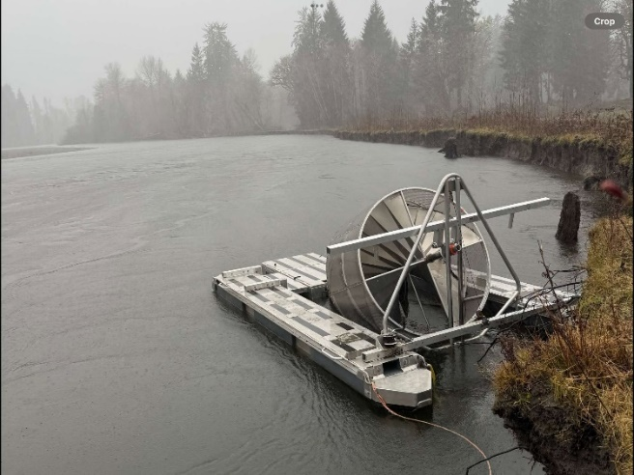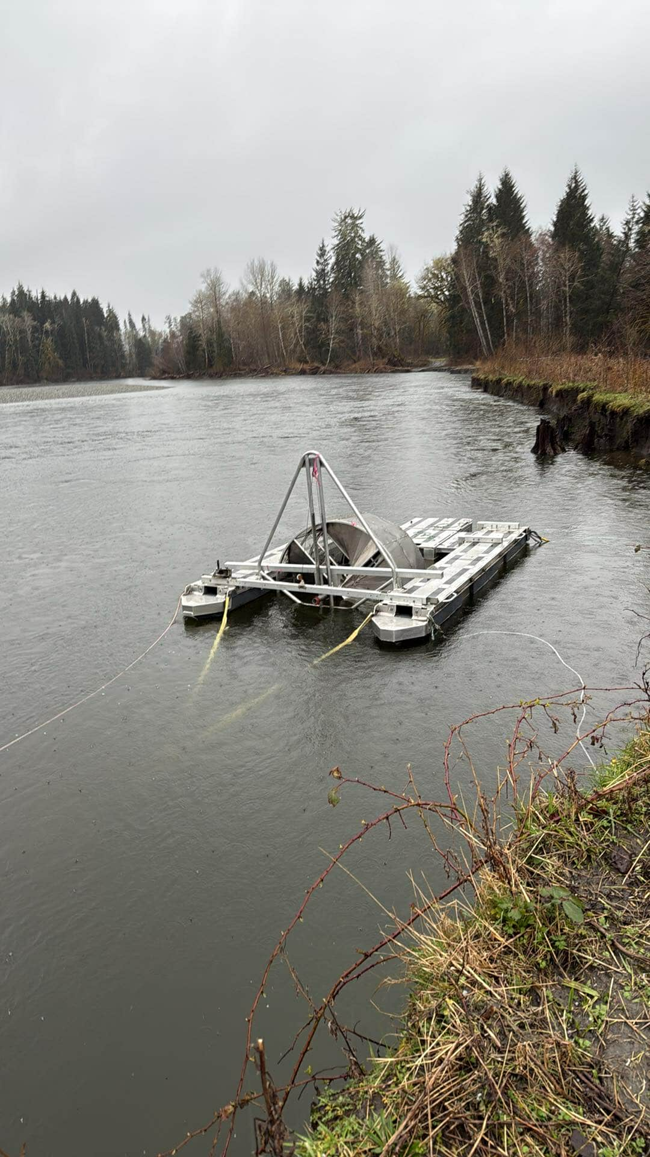

A)

B)

Stump 2

Stump 1

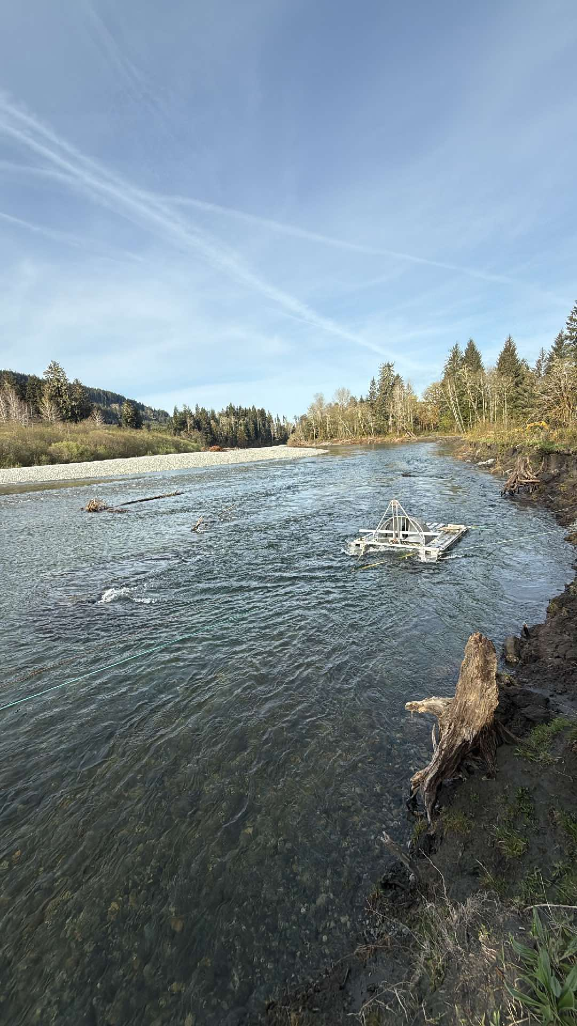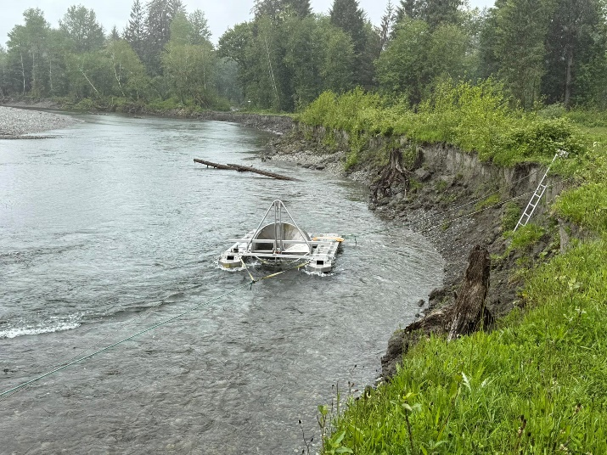

C)

D)

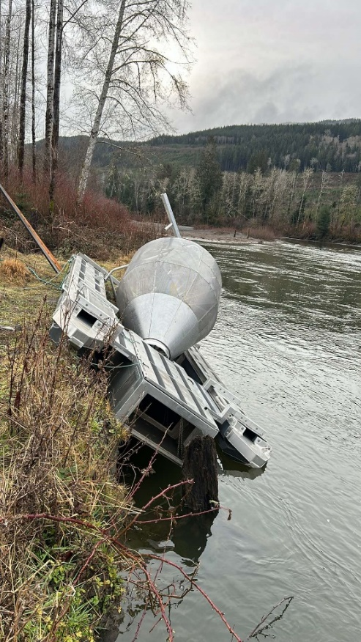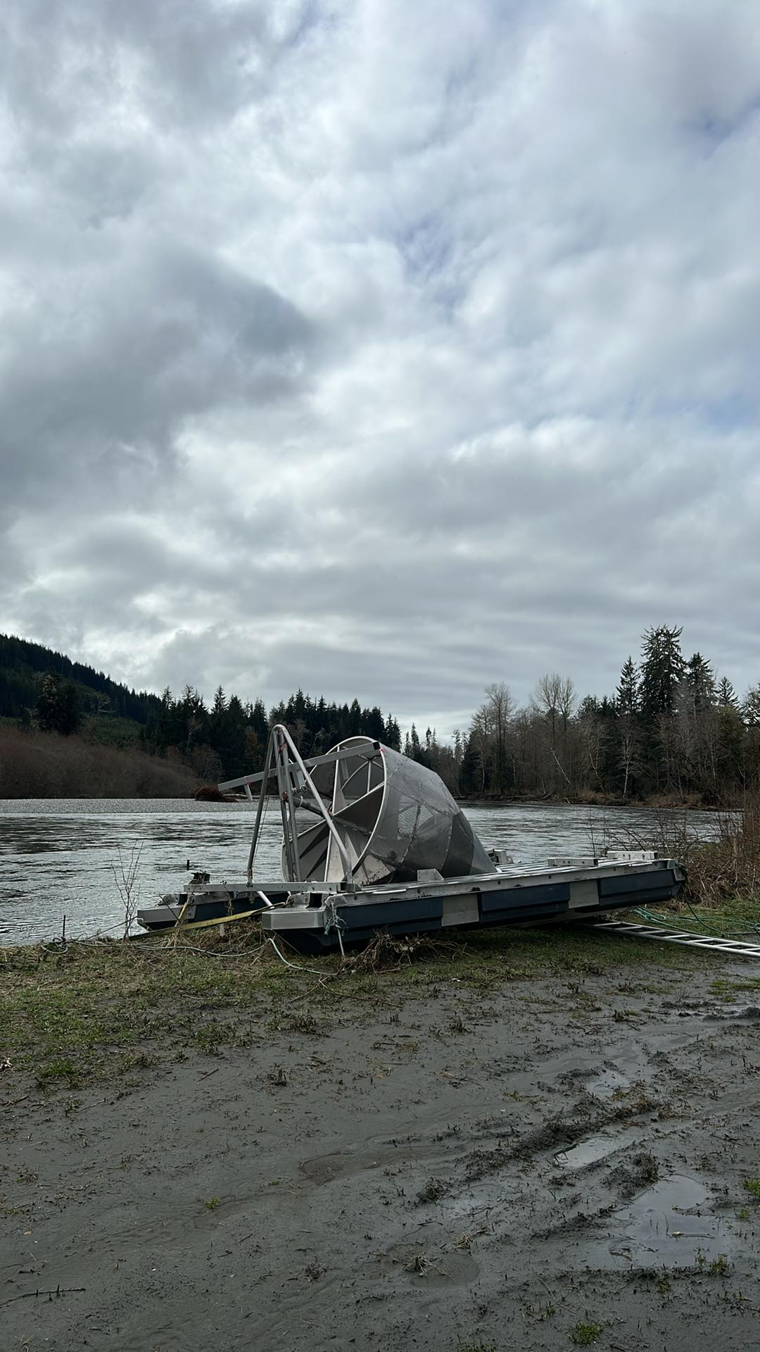

E)

F)

Figure xx. The RST at different water levels during 2025. Note the position of the two stumps in photos for orientation. A) February 24, water at approx. 4 m or 175 m3/s, B) March 21 water at approx. 3.9 m or 160 m3/s, c) April 14, water at approx. 2.8 m or 36 m3/s, d) May 19 water at appox. 2.4 m or 14 m3/s. In e) February 22-23 and f) March 23-24, levels exceeded the bank height and the RST was deposited on the ground on top of the bank; these events corresponded to 5.7 m or 450 m3/s and 5.75 m or 500 m3/s, respectively. At high flows above approx. 150 m3/s the site becomes a back-eddy and the trap spins slowly (or hardly at all). This is ideal for avoiding logs and reducing damage to the trap, but not for fish capture.

## ABUNDANCE ESTIMATES

### Infilling for missed/unfished days

Model evaluation metrics are provided below for each species/life history type, followed by figures showing infilling results.

Table xx. All infilling models considered by year and species/life history type with associated metrics. Mean absolute error (MAE) was calculated with and without zero points why?. Mean absolute scaled error (MASE) and mean absolute percentage error (MAPE) are also given, although MAPE was not considered a strong metric as it cannot be calculated for observed zeroes.

|  |  |  |  |  |  |  |
| --- | --- | --- | --- | --- | --- | --- |
| **Year** | **Infilling model name** | **MAPE** | **MAE_w0** | **MAE_no0** | **MASE** | **Notes** |
| 2024 | chinook_natural_kal.structs | 1.213 | 6.007 | 6.820 | 0.443 | Model selected |
| 2024 | chinook_natural_interp.linear | 1.245 | 6.446 | 7.396 | 0.475 |  |
| 2024 | ~~chinook_natural_interp.stine~~ | ~~1.219~~ | ~~6.501~~ | ~~7.227~~ | ~~0.479~~ | Excluded – predicted negative catch |
| 2024 | ~~chinook_natural_kal.arima~~ | ~~1.712~~ | ~~7.456~~ | ~~8.159~~ | ~~0.549~~ | Excluded – predicted negative catch |
| 2024 | chinook_natural_MA.exp3 | 1.285 | 7.727 | 8.811 | 0.569 |  |
| 2024 | chinook_natural_MA.exp2 | 1.333 | 7.769 | 8.852 | 0.572 |  |
| 2024 | chinook_natural_MA.linear3 | 1.116 | 7.828 | 8.650 | 0.577 |  |
| 2024 | chinook_natural_MA.linear2 | 1.195 | 7.898 | 8.719 | 0.582 |  |
| 2024 | chinook_natural_MA.simp3 | 0.874 | 7.958 | 8.458 | 0.586 |  |
| 2024 | chinook_natural_MA.simp2 | 0.993 | 8.063 | 8.563 | 0.594 |  |
| 2025 | chinook_natural_interp.linear | 0.948 | 4.930 | 12.856 | 0.555 | Model selected |
| 2025 | chinook_natural_kal.arima | 0.948 | 4.930 | 12.856 | 0.555 |  |
| 2025 | chinook_natural_kal.structs | 0.948 | 4.930 | 12.856 | 0.555 |  |
| 2025 | ~~chinook_natural_interp.stine~~ | ~~1.071~~ | ~~5.251~~ | ~~13.230~~ | ~~0.592~~ | Excluded – predicted negative catch |
| 2025 | chinook_natural_MA.simp2 | 0.649 | 5.278 | 13.130 | 0.595 |  |
| 2025 | chinook_natural_MA.simp3 | 0.649 | 5.278 | 13.130 | 0.595 |  |
| 2025 | chinook_natural_MA.linear2 | 0.800 | 5.351 | 13.155 | 0.603 |  |
| 2025 | chinook_natural_MA.linear3 | 0.800 | 5.351 | 13.155 | 0.603 |  |
| 2025 | chinook_natural_MA.exp2 | 0.921 | 5.433 | 13.196 | 0.612 |  |
| 2025 | chinook_natural_MA.exp3 | 0.921 | 5.433 | 13.196 | 0.612 |  |
| 2024 | chinook_hatchery |  |  |  |  |  |
| 2025 | chinook_hatchery |  |  |  |  |  |
| 2024 | coho_subyearling_kal.arima | 0.935 | 67.175 | 67.175 | 0.252 | Model selected |
| 2024 | ~~coho_subyearling_interp.stine~~ | ~~1.609~~ | ~~91.931~~ | ~~91.931~~ | ~~0.344~~ | Excluded – predicted negative catch |
| 2024 | coho_subyearling_kal.structs | 2.343 | 93.723 | 93.723 | 0.351 |  |
| 2024 | coho_subyearling_interp.linear | 1.293 | 95.357 | 95.357 | 0.357 |  |
| 2024 | coho_subyearling_MA.exp3 | 1.313 | 138.347 | 138.347 | 0.518 |  |
| 2024 | coho_subyearling_MA.exp2 | 1.318 | 138.460 | 138.460 | 0.519 |  |
| 2024 | coho_subyearling_MA.linear3 | 1.147 | 145.179 | 145.179 | 0.544 |  |
| 2024 | coho_subyearling_MA.linear2 | 1.164 | 145.569 | 145.569 | 0.545 |  |
| 2024 | coho_subyearling_MA.simp3 | 0.911 | 155.292 | 155.292 | 0.582 |  |
| 2024 | coho_subyearling_MA.simp2 | 0.940 | 156.000 | 156.000 | 0.584 |  |
| 2025 | coho_subyearling_MA.simp2 | 3.070 | 43.815 | 43.815 | 1.172 | Model selected |
| 2025 | coho_subyearling_MA.simp3 | 3.070 | 43.815 | 43.815 | 1.172 |  |
| 2025 | coho_subyearling_MA.linear2 | 3.866 | 52.174 | 52.174 | 1.396 |  |
| 2025 | coho_subyearling_MA.linear3 | 3.866 | 52.174 | 52.174 | 1.396 |  |
| 2025 | coho_subyearling_interp.linear | 4.413 | 56.831 | 56.831 | 1.521 |  |
| 2025 | coho_subyearling_kal.structs | 4.413 | 56.831 | 56.831 | 1.521 |  |
| 2025 | coho_subyearling_MA.exp2 | 4.509 | 58.944 | 58.944 | 1.577 |  |
| 2025 | coho_subyearling_MA.exp3 | 4.509 | 58.944 | 58.944 | 1.577 |  |
| 2025 | ~~coho_subyearling_kal.arima~~ | ~~4.893~~ | ~~60.562~~ | ~~60.562~~ | ~~1.620~~ | Excluded – predicted negative catch |
| 2025 | ~~coho_subyearling_interp.stine~~ | ~~5.282~~ | ~~63.144~~ | ~~63.144~~ | ~~1.689~~ | Excluded – predicted negative catch |
| 2024 | coho_yearling_interp.stine | 1.599 | 3.099 | 3.610 | 0.542 | Model selected |
| 2024 | coho_yearling_interp.linear | 1.700 | 3.232 | 3.668 | 0.566 |  |
| 2024 | coho_yearling_MA.simp3 | 1.758 | 3.438 | 3.563 | 0.602 |  |
| 2024 | coho_yearling_MA.linear3 | 1.823 | 3.449 | 3.491 | 0.604 |  |
| 2024 | coho_yearling_MA.exp3 | 1.877 | 3.458 | 3.437 | 0.605 |  |
| 2024 | coho_yearling_MA.exp2 | 1.909 | 3.481 | 3.413 | 0.609 |  |
| 2024 | coho_yearling_MA.linear2 | 1.877 | 3.490 | 3.451 | 0.611 |  |
| 2024 | coho_yearling_MA.simp2 | 1.841 | 3.500 | 3.500 | 0.613 |  |
| 2024 | coho_yearling_kal.structs | 1.353 | 3.545 | 3.983 | 0.620 |  |
| 2024 | coho_yearling_kal.arima | 1.000 | 4.125 | 5.125 | 0.722 |  |
| 2025 | coho_yearling_kal.arima | 0.768 | 0.542 | 0.816 | 1.083 | Model selected |
| 2025 | coho_yearling_interp.linear | 1.014 | 0.750 | 0.935 | 1.500 |  |
| 2025 | ~~coho_yearling_interp.stine~~ | ~~1.075~~ | ~~0.781~~ | ~~0.996~~ | ~~1.562~~ | Excluded – predicted negative catch |
| 2025 | coho_yearling_MA.simp2 | 1.083 | 0.833 | 0.944 | 1.667 |  |
| 2025 | coho_yearling_MA.simp3 | 1.083 | 0.833 | 0.944 | 1.667 |  |
| 2025 | coho_yearling_MA.linear2 | 1.138 | 0.851 | 0.999 | 1.703 |  |
| 2025 | coho_yearling_MA.linear3 | 1.138 | 0.851 | 0.999 | 1.703 |  |
| 2025 | coho_yearling_MA.exp2 | 1.178 | 0.863 | 1.041 | 1.726 |  |
| 2025 | coho_yearling_MA.exp3 | 1.178 | 0.863 | 1.041 | 1.726 |  |
| 2025 | coho_yearling_kal.structs | 0.974 | 1.110 | 0.777 | 2.220 |  |

Figure xx. Observed (black) and infilled (coloured) natural-origin Chinook counts for 2024 and 2025. Black circles represent observed counts. Black crosses indicate observed counts removed from the dataset prior in order to assess infilling model performance (validation data set).

[hatchery chinook]

Figure xx. Observed (black) and infilled (coloured) sub-yearling Coho counts for 2024 and 2025. Black circles represent observed counts. Black crosses indicate observed counts removed from the dataset prior in order to assess infilling model performance (validation data set).

Figure xx. Observed (black) and infilled (coloured) yearling Coho counts for 2024 and 2025. Black circles represent observed counts. Black crosses indicate observed counts removed from the dataset prior in order to assess infilling model performance (validation data set).

## Coho life history identification

We primarily used size as an indication as to whether Coho were classified as fry (sub-yearlings) or smolts (yearlings). Alevin were the exception, where Coho were only classified as alevin if there was still evidence of a yolk sack (i.e., the fish was not “buttoned-up”). Figure A1 indicates size is a reasonable indicator to separate these life history types.

Figure A1. Fork length of Coho visually grouped into one of three life history stages: alevin, fry (sub-yearling), or smolts (yearling). Dashed lines represent group means.

## Using fish height as a proxy for weight

We also explored whether height could be used as a proxy for wet weight. While this did not impact this specific study, it may be useful in future when a weigh scale is unavailable, or as additional data to ground-truth weights. To examine this relationship, we fit an exponential model to the full Chinook dataset which included fish sampled from the RST, beach and purse seine sampling (published in a separate report).

Although the relationship between height and weight in the full dataset was significant (Table xx, Figure xxa), it appeared that at small body size (RST) the model tended to over-estimate weight, while at larger body size (purse seine) it would be more likely to under-estimate weight (Figure xxa). Log-transformation did not improve the relationship when all fish were considered. Therefore we separated the data into two datasets to model the relationship between height and weight: freshwater (RST) and early marine (beach and purse seine), and fit separate models to each of these life stages (Figure xx).

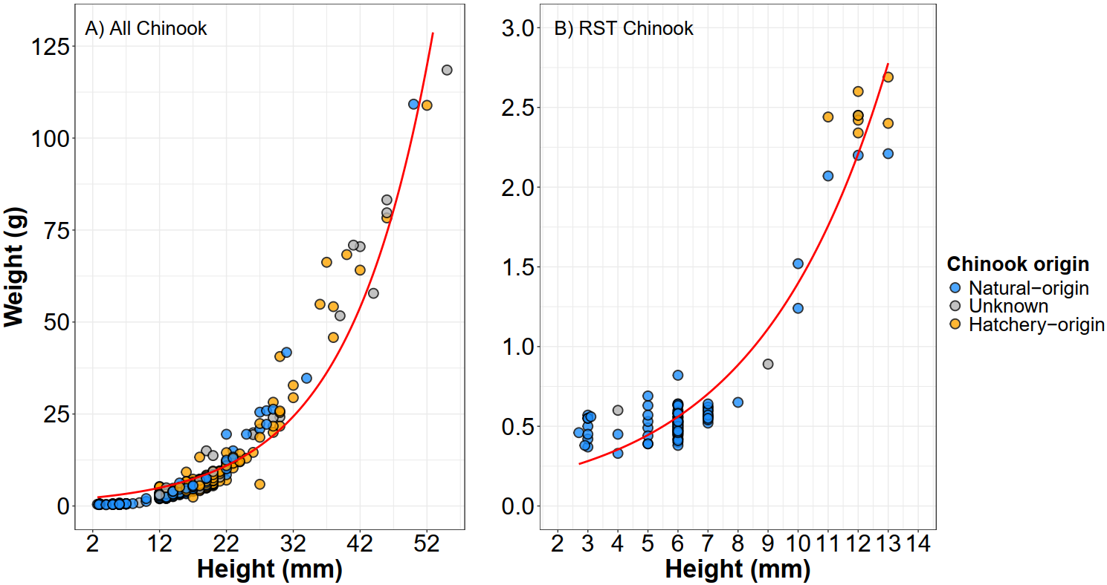

$$y= 1.93{∙e}^{\left(0.08∙x\right)}$$

$$y= 0.14{∙e}^{\left(0.23∙x\right)}$$

Figure xx. a) Exponential model fit to all fish sampled from all methods including the RST, beach seine, and purse seine, and b) exponential model fit to fish from the RST only. Models were fit using the *nls* function in R (unweighted).

The RST-only model still retained a clear significant relationship between height and weight (*p* < 0.01, *R2* = 0.92; Table 1), with the model appearing to better represent the height-weight relationship. We also explored the use of a Gompertz model to fit to the RST-only Chinook relationship as well, but the model did not provide an improved fit and would have been challenging to implement in future predictions. However, caution should be exercised when trying to use the exponential model in Figure xxb above to predict weights outside of the observed data ranges. Exponential models assume infinite growth which is not biologically plausible above a certain fish height and weight. The length-height relationship for the beach and purse seine fish will be provided in a separate report.

Table x. Parameter estimates and statistics for exponential models fit to the full dataset and RST-only dataset (corresponds to Figure xxa and xxb, respectively).

|  |  |  |  |  |  |  |
| --- | --- | --- | --- | --- | --- | --- |
| **Model** | **Parameter** | **Estimate ± SE** | **t-value** | **p-value** | **R2** | **RMSE** |
| Full dataset | *A* | 1.929874 ± 0.091215 | 21.16 | <0.01 | 0.912 | 4.61 |
| *b* | 0.079375 ± 0.001075 | 73.82 | <0.01 |
| RST-only | *A* | 0.14181 ± 0.01057 | 13.41 | <0.01 | 0.923 | 0.174 |
| *b* | 0.22884 ± 0.00684 | 33.46 | <0.01 |